* Git init - Initialize the repository

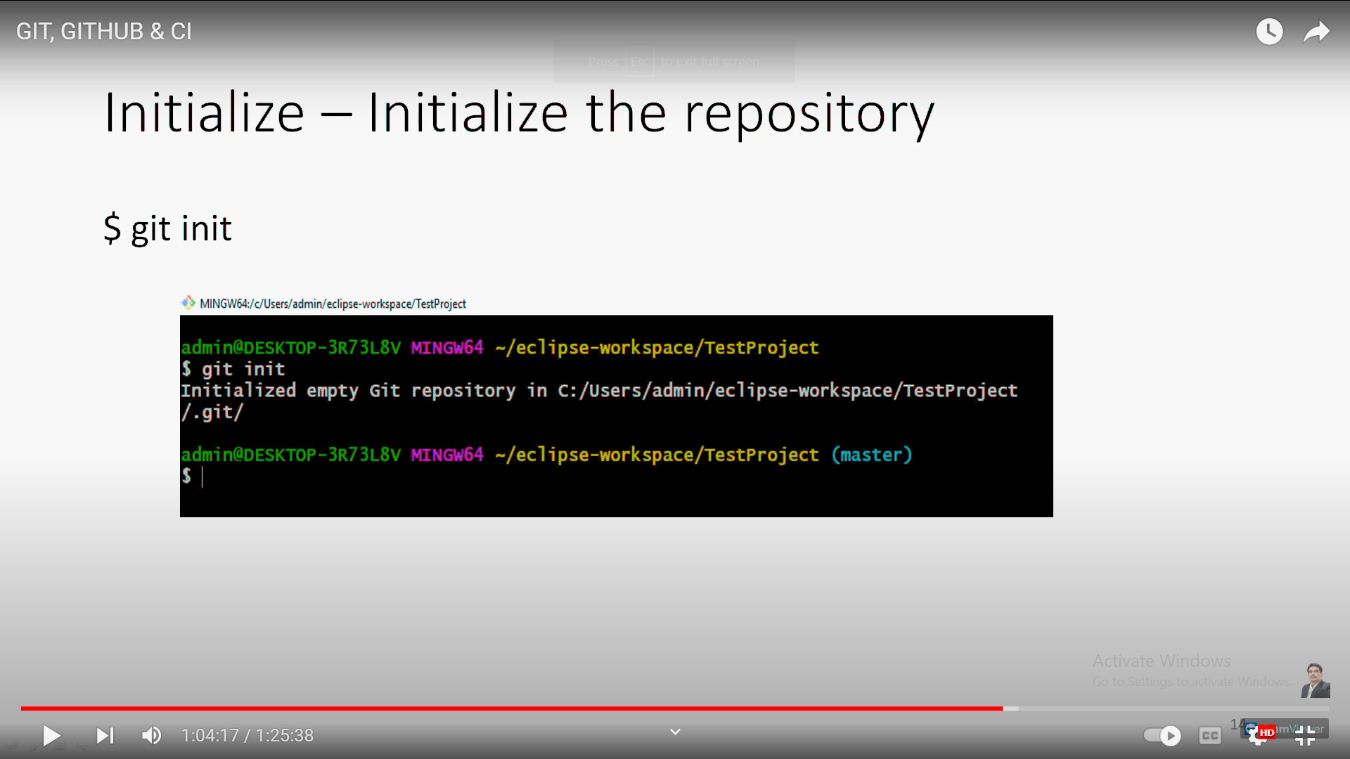

Git to GitHub connection

* Git remote add origin “URL of the repository”

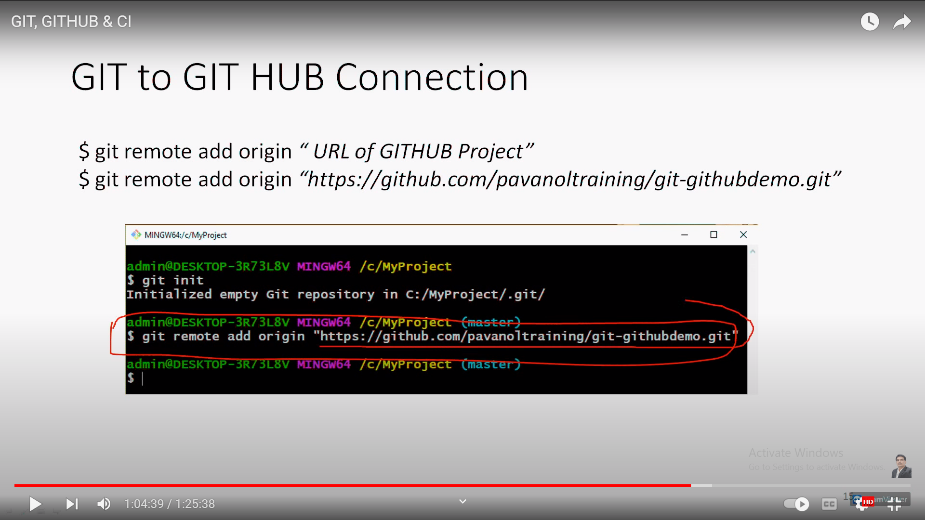

* Pull the files from Remote repository to local repository
* Git pull origin main / master

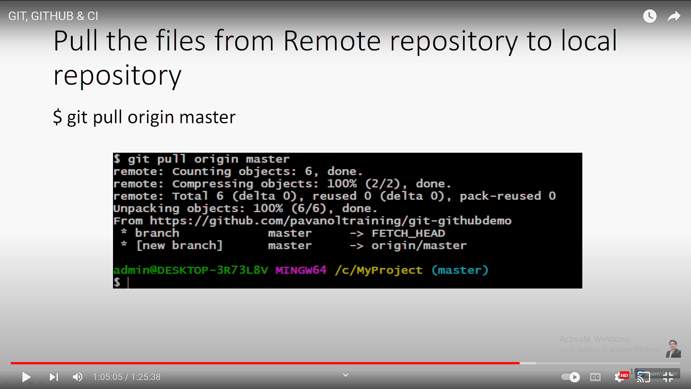

* Git status command
* Create text1.txt file and add git status command
* 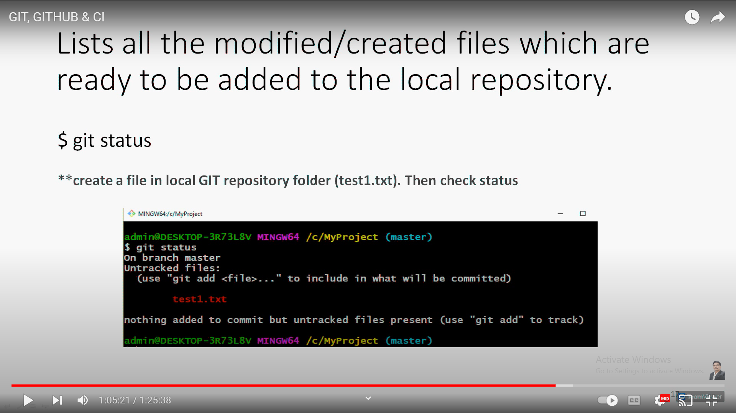
* Git add text1.txt

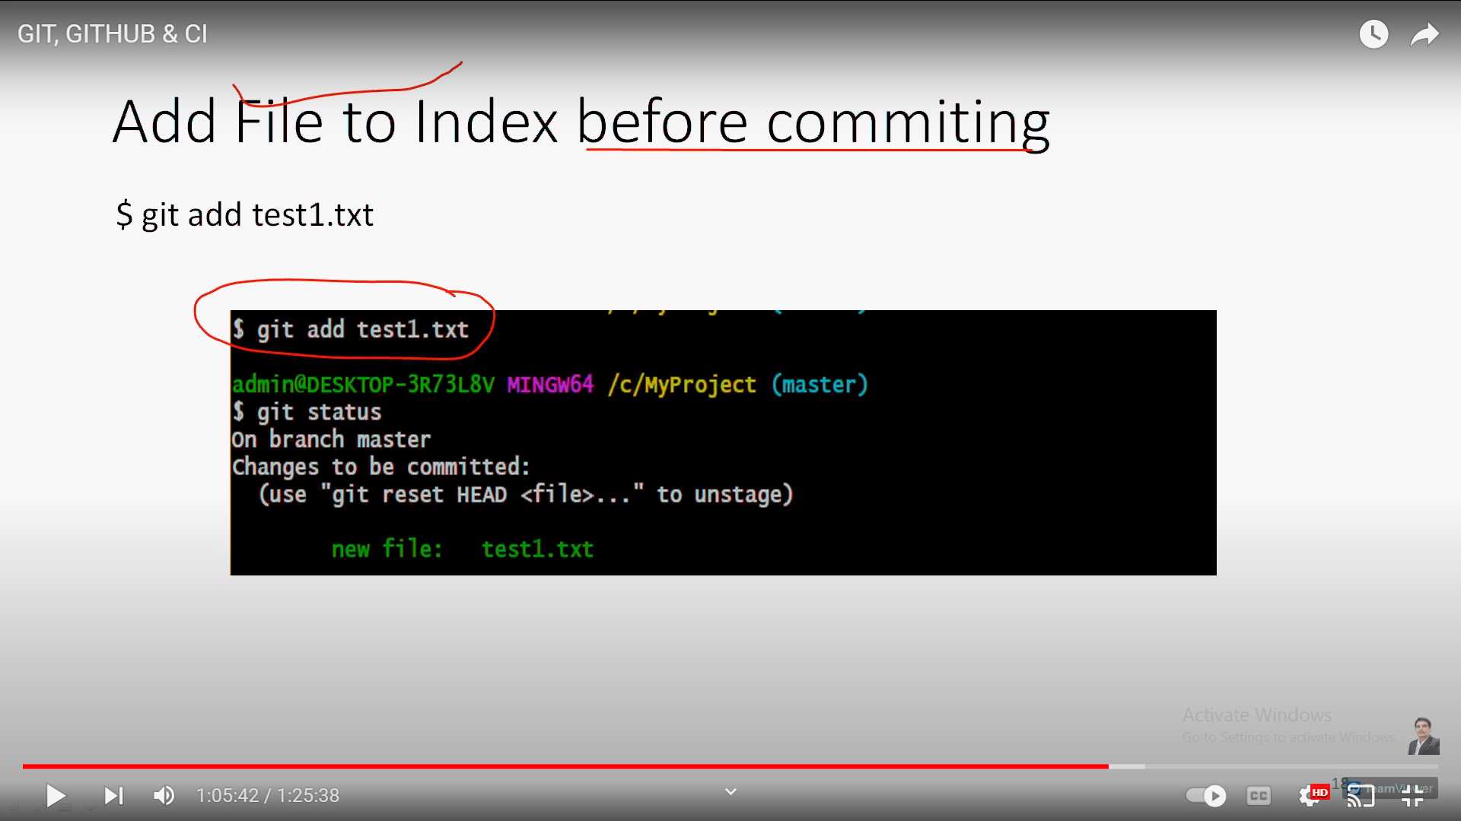

* Commiting single file into git repository
* Git commit –m “<message>”
* 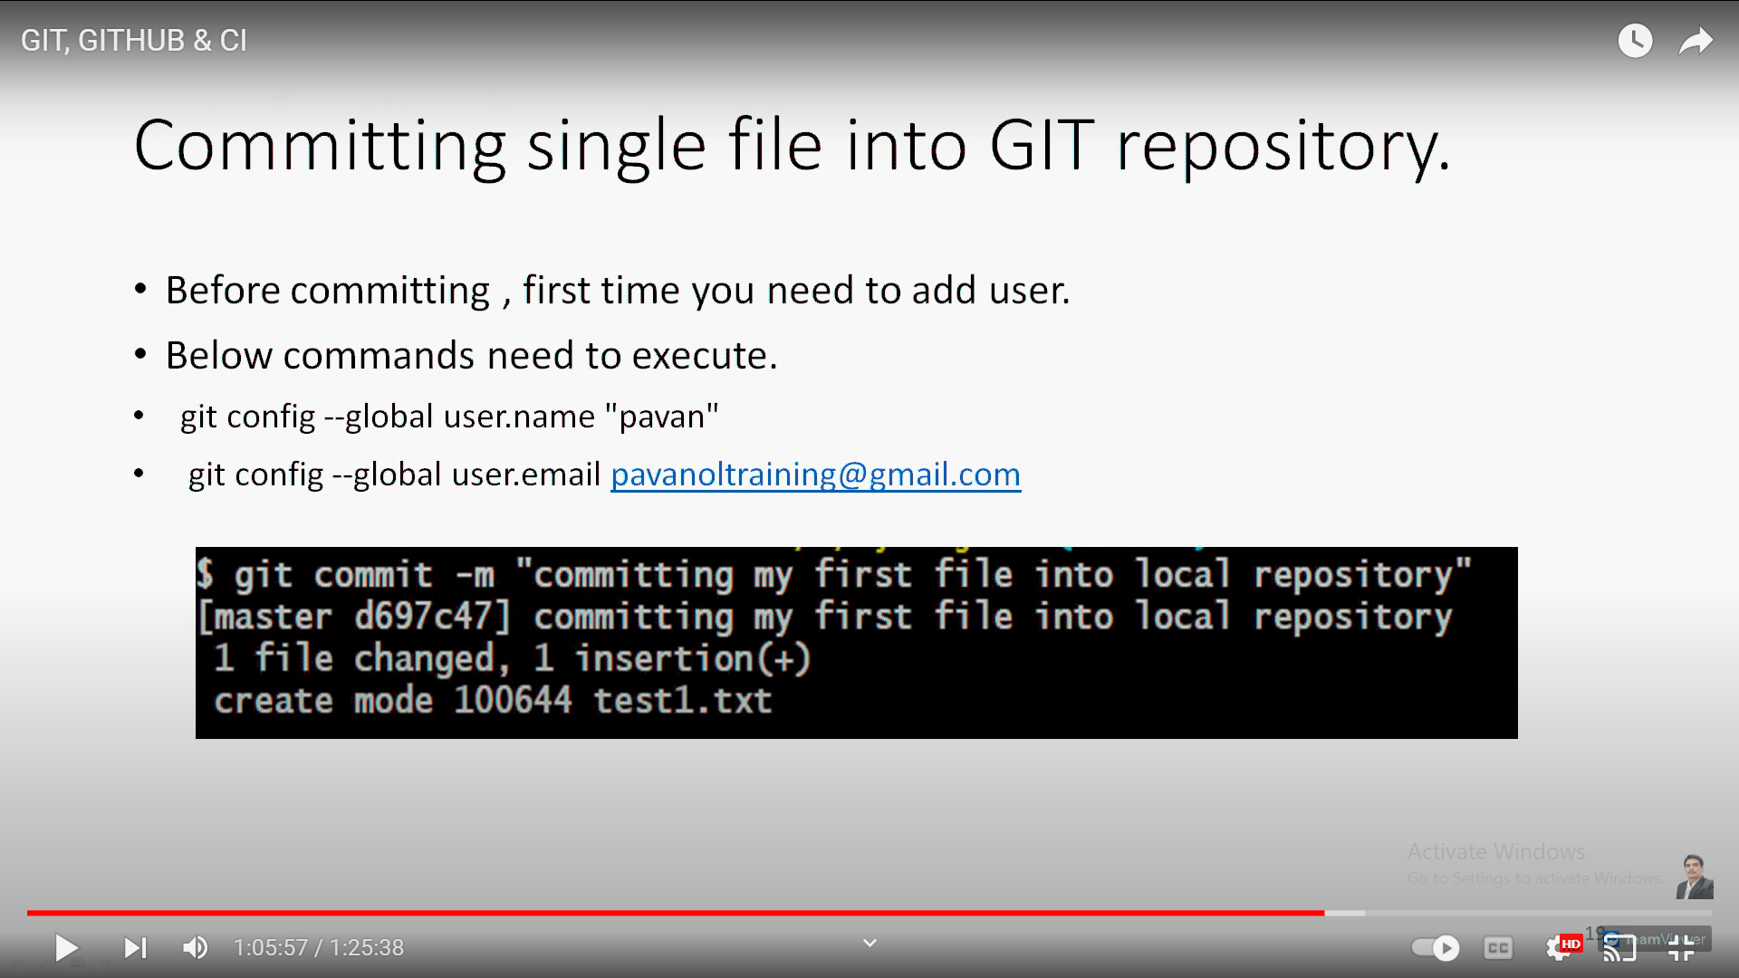
* Commiting multiple files ---
* Add the files at the local folders and add into git
* Ex- text1.txt , text2.txt
* Then go to git bash and git add –A
* Git commit –a –m “<commit message>”

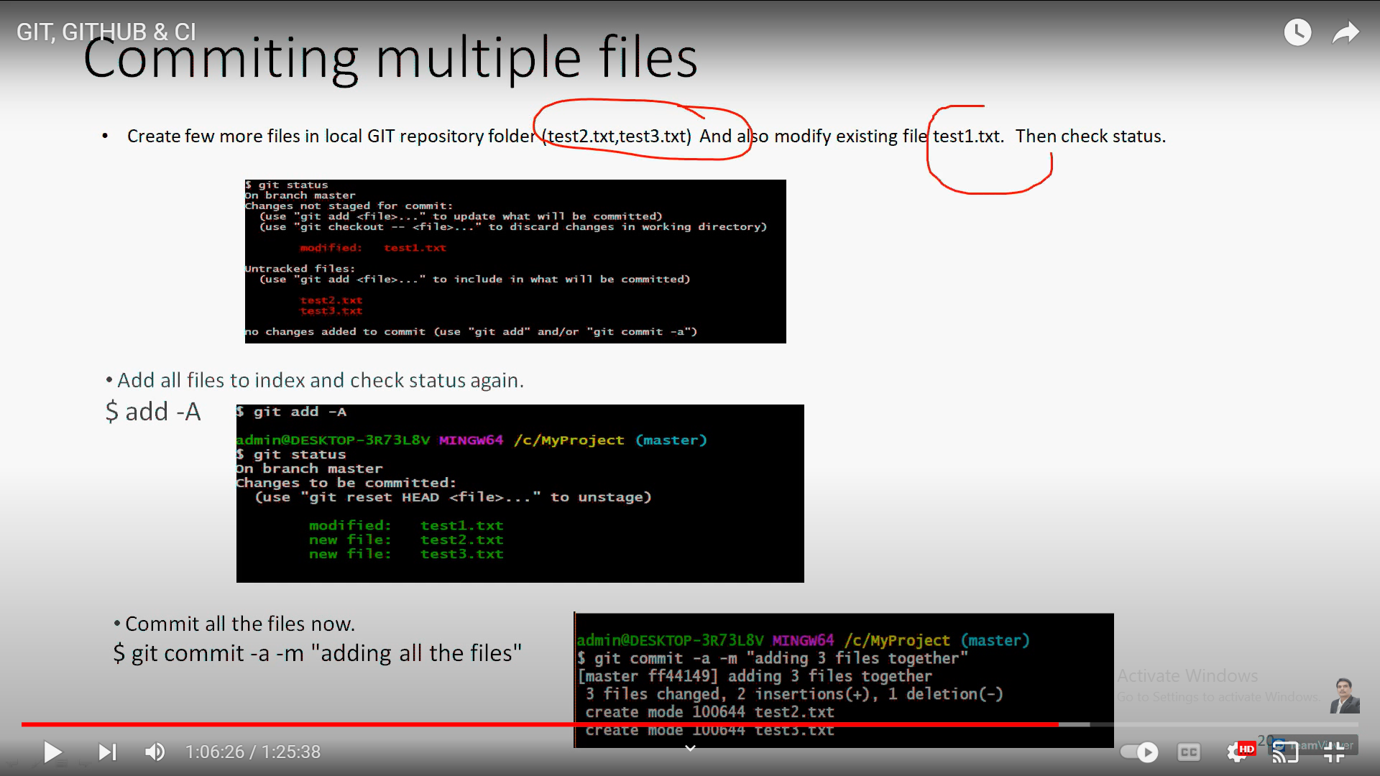

* Before pushing the files into git remote repo we need to pull the files
* Git pull origin master

